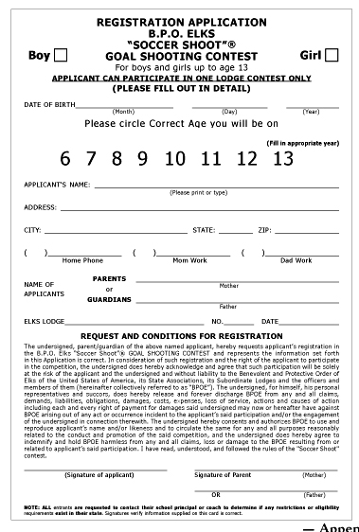
January 1, 2026
6 7 8 9 10 11 12 13 14 15
For boys and girls up to age 15

Email Address

NJ

